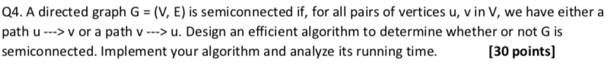

A.4 :

**Claim:**

A DAG is semi connected in a topological sort, for each i, there there is an edge (vi,vi+1)

**Proof :**

-> Given a DAG with topological sort v1,v2,...,vn :

-> There is off-course No Path (vi+1, vi) because it’s a topological sort of DAG, and now for graph to be semi-connected , there has to exist an edge from (vi,vi+1) .

-> So, If for every i there is an edge (vi,vi+1), then for each i,j (i < j) there is a path vi->vi+1->...->vj-1->vj, and the graph is semi connected.

**Algorithm :**

1. Find **Maximal SCCs** in a graph .
2. Make a condensed graph using it, the condensed graph will definitely be a **Directed Acyclic Graph.**
3. Now find **Topological Ordering** of the condensed graph.Let it be (v1,v2,v3,...vn)
4. Now check for the condition that for each ‘i’, there should be an edge from (vi,vi+1).

Source : <https://stackoverflow.com/a/30642807>

**Code :** [**https://ideone.com/gdtgQn**](https://ideone.com/gdtgQn)